## How to configure and install the various components created in the steps

### Step 1

1. Open up SQL Server Management Studio.
2. Connect to the server of your choice.
3. Navigate to .\DerivcoTest\Step1
4. Open the file “SQL_DatabaseInstallation.sql” with SQL Server Management Studio and click the “Execute” button located in the toolbar.
   1. 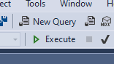
5. You should get a “Command completed successfully” message.
6. Now you have created and populated the tables for the database we will be using to conduct our queries for the test.
7. Open the file “CreateStoredProcedure_Query.sql” with SQL Server Management Studio and click the “Execute” button located in the toolbar.
   1. 
8. You should get a “Command completed successfully” message.
9. Now you have created the stored procedure that we will be using to execute our commands.
10. Open the file “UnitTest_Queries.sql” with SQL Server Management Studio and click the “Execute” button located in the toolbar.
    1. 
11. You should see four tables in the results tab
    1. 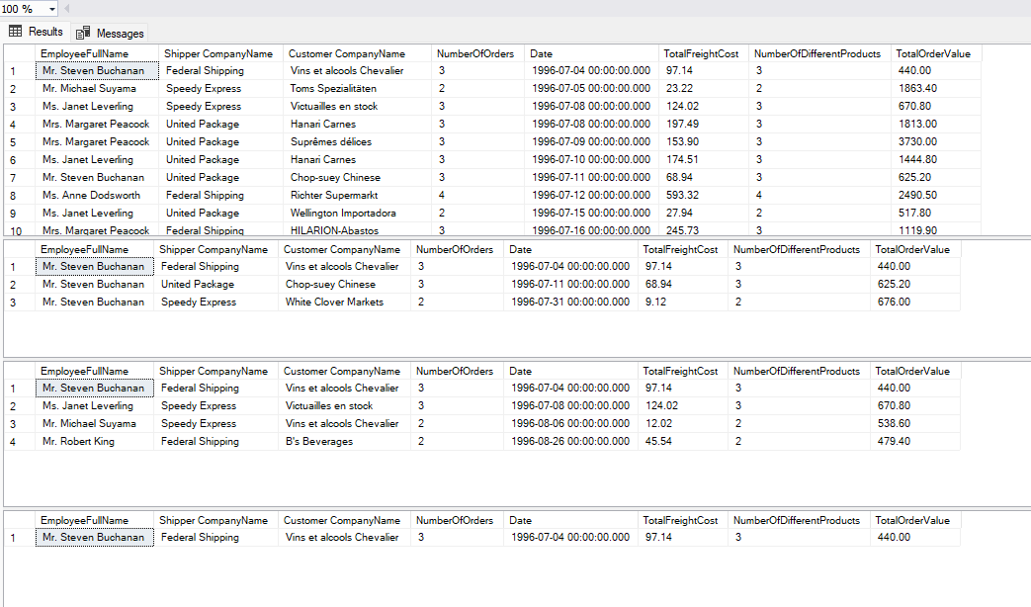
12. These four tables are the results of the four different commands we executed on the stored procedure that we just made on the database we just created and populated.